**Impeller Design Notes**

Open impeller clearances:

* ~0.008” to 0.015” from impeller face to case (0.2 to 0.5 mm)
  + 1% of pump efficiency is lost for each 0.002” deviation from this range

This makes sense when comparing to 1st EFS design. Their impeller was **very** snug

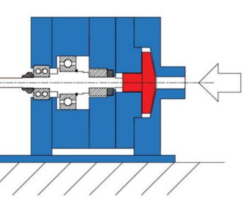

*HOWEVER*, we cannot allow the impeller to make contact with the case, as this will result in potential sparks and ignition of LOX